**Southwest Modernism**

Southwest modernismrefers to modern artists who were drawn to the style and subject matter of indigenous and Spanish colonial culture in the American Southwest, especially during the first half of the twentieth century. For some, the appropriation of uniquely American subject matter helped distinguish their practice from European modernism at a time of great transatlantic collaboration. The rugged landscape, distinctive architecture and colorful Native American and Hispanic religious artifacts appealed to those who had grown weary of modern city dwelling. Such an appropriation of rural, native and non-Western visual and material culture has always been vital for the development of modernism. Known as primitivism, this phenomenon is based on the belief that unencumbering oneself from the complexities of urban life leads to more intuitive and innovative forms of expression. Representative artists include Ernest Blumenschein, Marsden Hartley, Georgia O’Keeffe and Joseph Henry Sharp. The remote village of Taos, New Mexico, was the center of these incoming artists’ fascination. Their artworks—largely paintings—are characterized by pictorial, post-Impressionist treatments of landscapes and Hispanic and native subjects, rendered in emotive colors, and sometimes including fantastical elements.

Bordered by the indigenous Taos Pueblo community, the surrounding area was already a multicultural hub by the time of its annexation to the United States. The Pueblo was a subject of ongoing fascination to white visitors and their counterparts in the East, who had read about indigenous ceremonies in popular magazines such as *Harper’s Weekly* and *McClure’s*. By 1915, there were enough white artists living in Taos to warrant the establishment of the Taos Society of Artists. The Taos Society brought significant and early nationwide exhibition opportunities to its members. Mabel Dodge Luhan, an heiress and fixture in the East Coast intelligentsia, also moved to Taos in 1919 and established a residential colony. Luhan hosted many of those who would become major influencers, including the writers D. H. Lawrence, Willa Cather and Robinson Jeffers, and the painters Marsden Hartley and Georgia O’Keeffe. In distinction from the Taos Society, Hartley’s and O’Keeffe’s practices demonstrated prior contact with the latest European modernism via Alfred Stieglitz and the 291 Gallery in New York. For instance, O’Keeffe’s *Black Cross New Mexico* (1929) was inspired by the artist’s view from Luhan’s property in Taos. Rather than depicting the cross as it was used in local religious pageantry, O’Keeffe deploys it as a compositional device to frame and stabilize space in the absence of conventional linear perspective. Thus O’Keeffe’s contact with the Southwest bolstered ideas about formalist abstraction already at work in her practice, which was a common experience for many who visited there.

**References and further reading**

Burke, F. (2008) *From Greenwich Village to Taos: primitivism and place at Mabel Dodge Luhan’s.* Lawrence: The University Press of Kansas.

Corn, W. (2001) *The great American thing: modern art and national identity.* Berkeley: The University of California Press.

Ott, J. (2009) ‘Reform in Redface: the Taos Society of Artists plays Indian’, *American Art* 23 (2): 80-107.

Witt, D. (2002) *Modernists in Taos: from Dasburg to Martin*. Santa Fe: Red Crane Books/Museum of New Mexico Press.

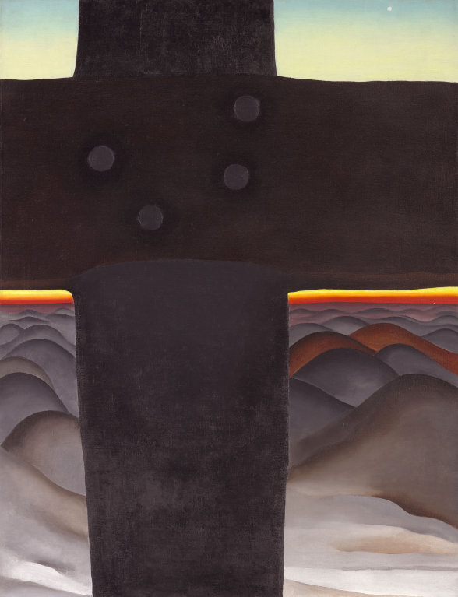

Georgia O’Keeffe, *Black Cross New Mexico*, 1929. Oil on canvas 99.1 x 76.2 cm (39 x 30 in.). Art Institute of Chicago. <http://www.artic.edu/aic/collections/artwork/46327>